Melissa Buist

CMPT 166

Homework #5

March 25, 2019

Homework 5 Tutorial

1. Create a Repository on GitHub

* Step 1: Go onto your preferred browser and go to github.com
* Step 2: Sign up or login in to your GitHub account
* A screenshot of a computer

  Description automatically generatedStep 3: Once in your account, click the ‘+’ button in the top right corner of the screen. A drop-down menu will show up and then you can click the ‘New Repository’ button as seen in Figure 1

Figure 1: Creating a Repository

* Step 4: You will then have to fill in the necessary boxes, such as naming your repository, adding a description, or making public or private. After filling in the required boxes, you’ll click the ‘Create Repository’ button as seen in Figure 2.

Figure 2: Naming and Creating the Repository

* Step 5: You have now created your own repository and can add code files and whatever else you think is necessary.

1. Check out the code
   * Step 1: In order to check out code, you’ll need to access a repository with code in it. After finding a repository, you’ll want to click the green ‘Clone or Download’ button. This will open a drop-down menu and you’ll then click download zip as seen in Figure 3.

Figure 3: Checking out the Code

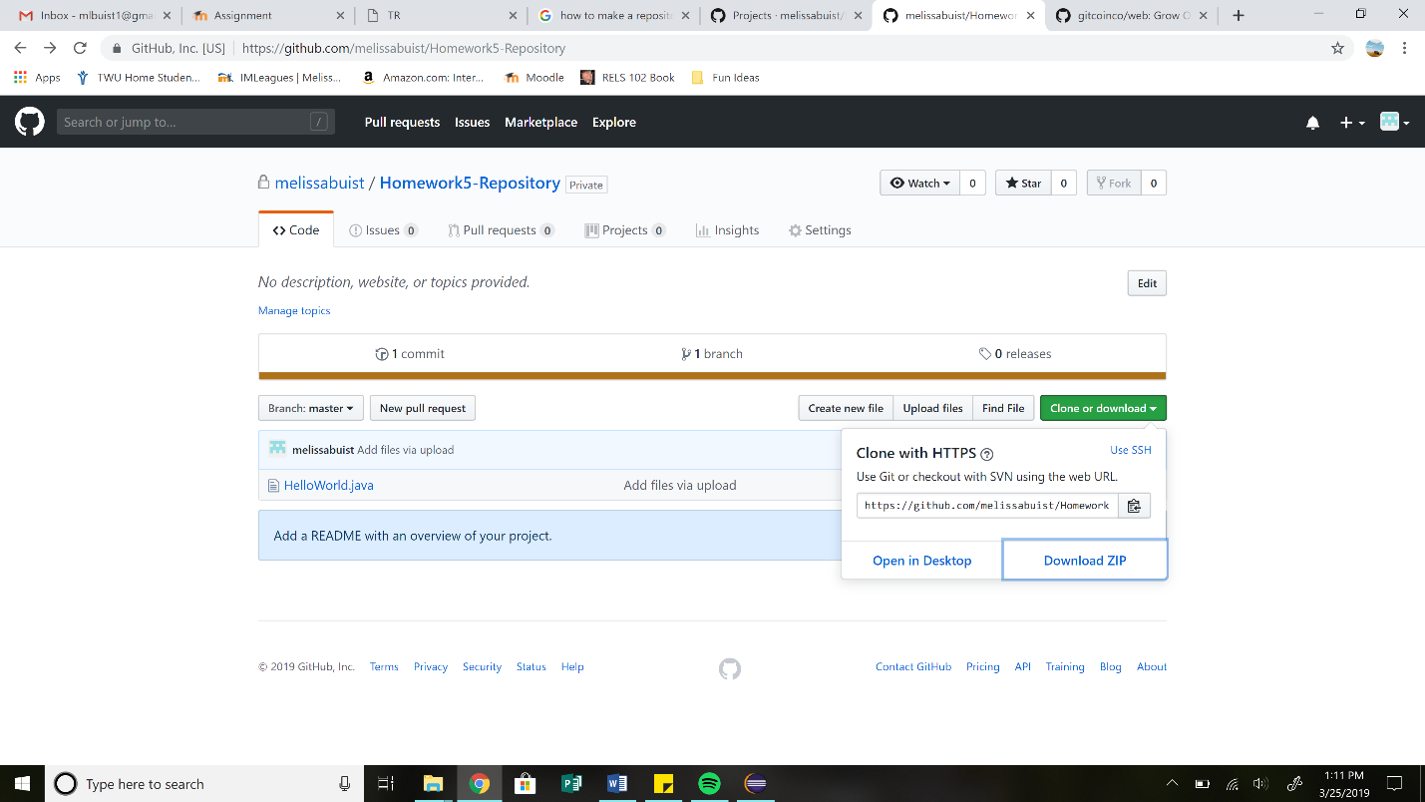

* + Step 2: You now have downloaded the file into your computer. You now want to open this file in Eclipse in order to edit the code.

1. Modify the Code
   * Step 1: Go into your downloads folder and open up the zip file. Now choose the java file that you want to edit and open it in Eclipse.

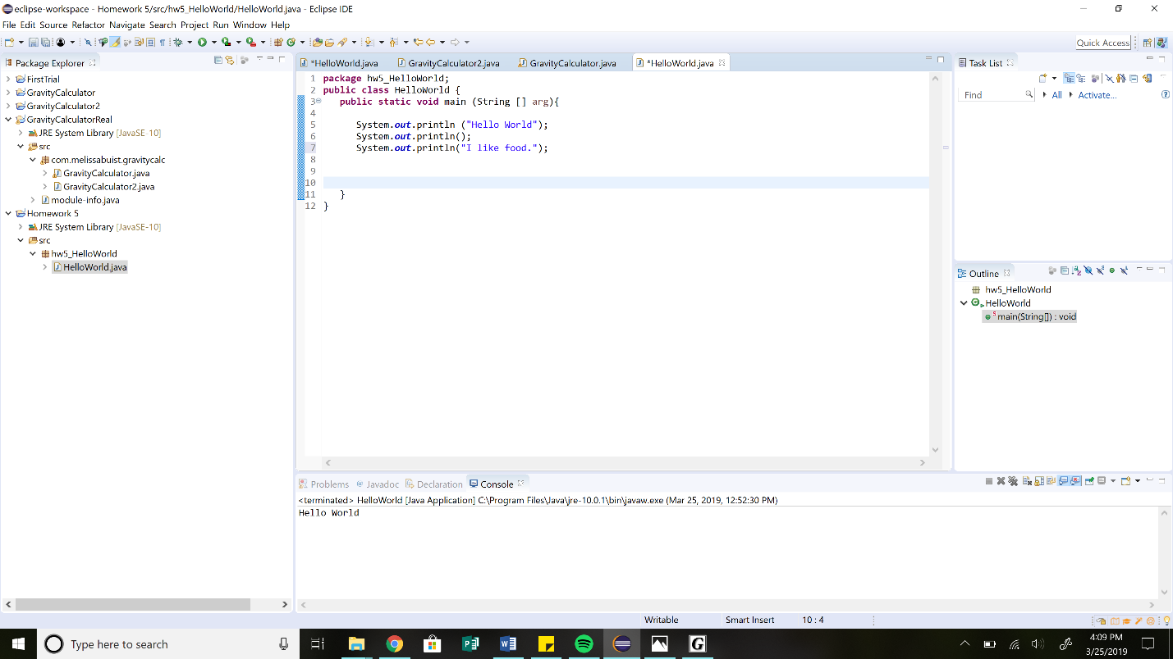

Figure 4: Editing Code

* + Step 2: Modify your code and save it as seen in Figure 4.

1. Check in Code
   * 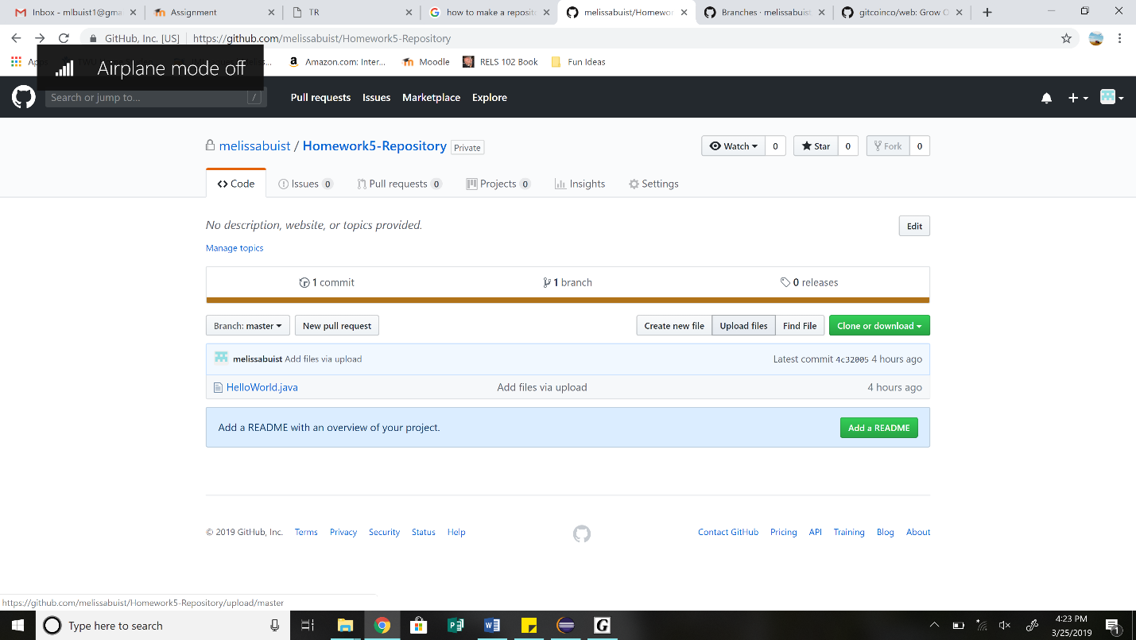Step 1: Go to GitHub in the repository that you want to check in your code and press the ‘upload files’ button as seen in Figure 5.

Figure 5: Uploading a File

* + Step 2: From there it will take you into a new page that gives the option to upload a file of your choice from your computer’s directories as seen in Figure 6. Choose the file that you want to upload to the repository and select it and press open. Finally press commit changes and the file will be uploaded.

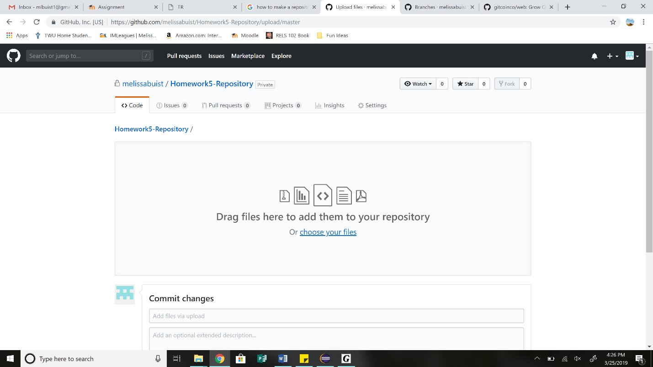

Figure 6: Choosing the file

* + Step 3: If the final uploaded file has the same name as an existing file in the GitHub repository, then it will replace that file and update it.

1. Verify the Modification is in the Repository
   * Step 1: You can verify the file you wanted to upload is in the repository by checking the news feed for the repository, in which it will say who has uploaded a file and how long ago it happened. You can also manually check to see if the file was changed in the repository.
2. Adding a Project to the Version Control
   * Step 1: To add a project to the version control, you first need to create a new project. In your repository, click the projects tab and on the new window that opens, press the bright green ‘create a project’ button as seen in Figure 7.

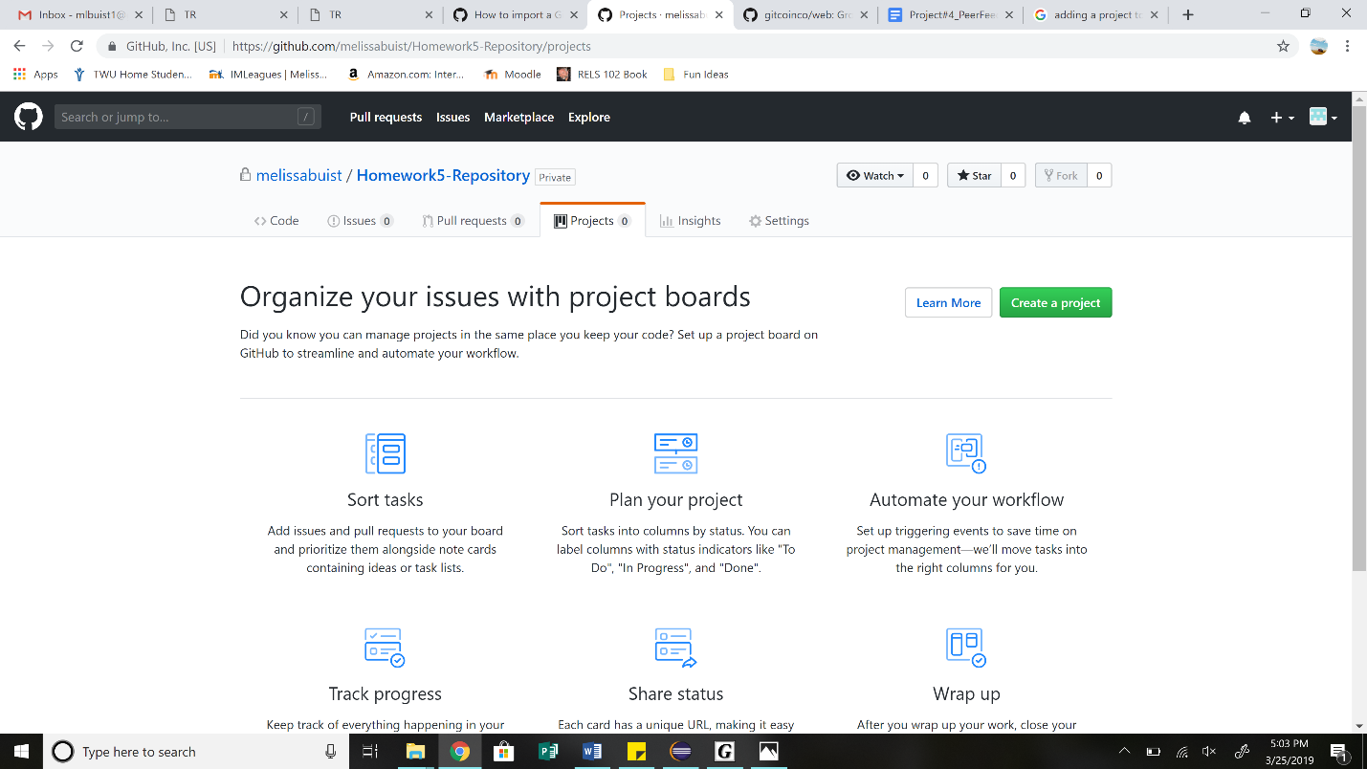

Figure 7: Creating a Project

* + Step 2: Name your new project and then click the ‘create project’ button on the bottom of your screen.
  + Step 3: You can now customize your project to have what layout you want and this should be used to help you keep your work organized.

1. Pick an existing code repository in GitHub and import the Git repository to your computer so you can work on the project.
   * Step1: Find a repository on GitHub that you would want to work on and click on the green ‘clone or download’ button in the top right corner and then press the ‘download zip’ button as seen in Figure 8.

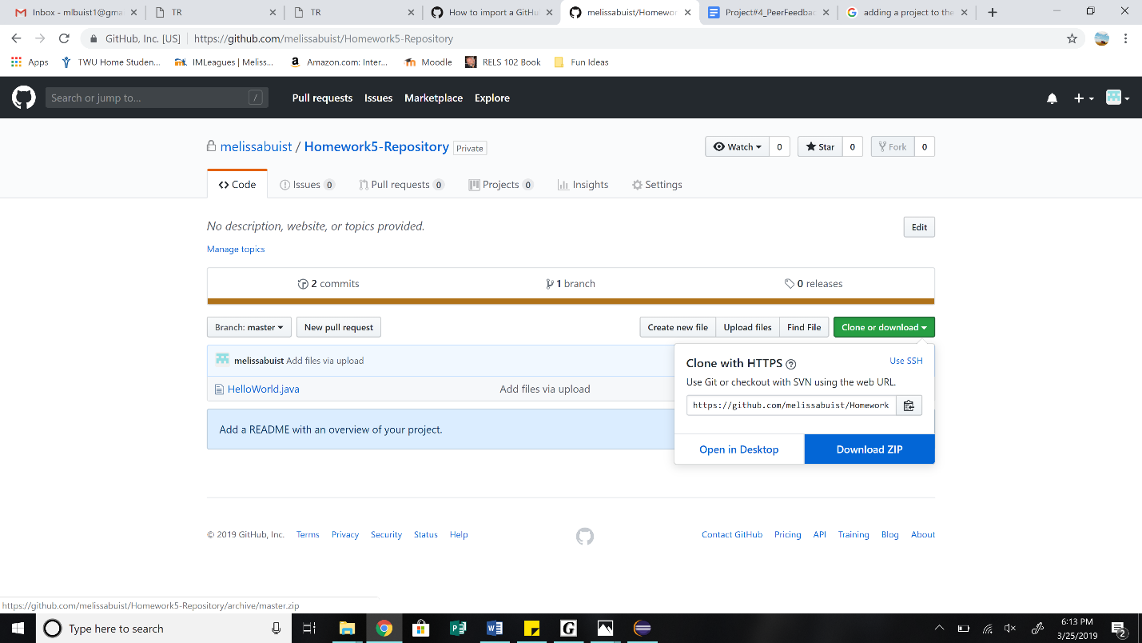

Figure 8: Naming and Creating the Repository

* + Step 2: When you download the zip file, it will go into your ‘downloads’ directory in your PC. From there, you can open the files in your IDE and manipulate them.